Harrow Bay News – Autumn 2026
Community newsletter – DRAFT
Tom Berger · 01 October 2026
Your update on the Harrow Bay Offshore Wind project – Autumn 2026

A substation at sea
On 19 August a heavy-lift vessel placed the 3,850-tonne offshore substation on its foundation in a single lift. The substation will collect the power from all 40 turbines and send it ashore through two export cables.
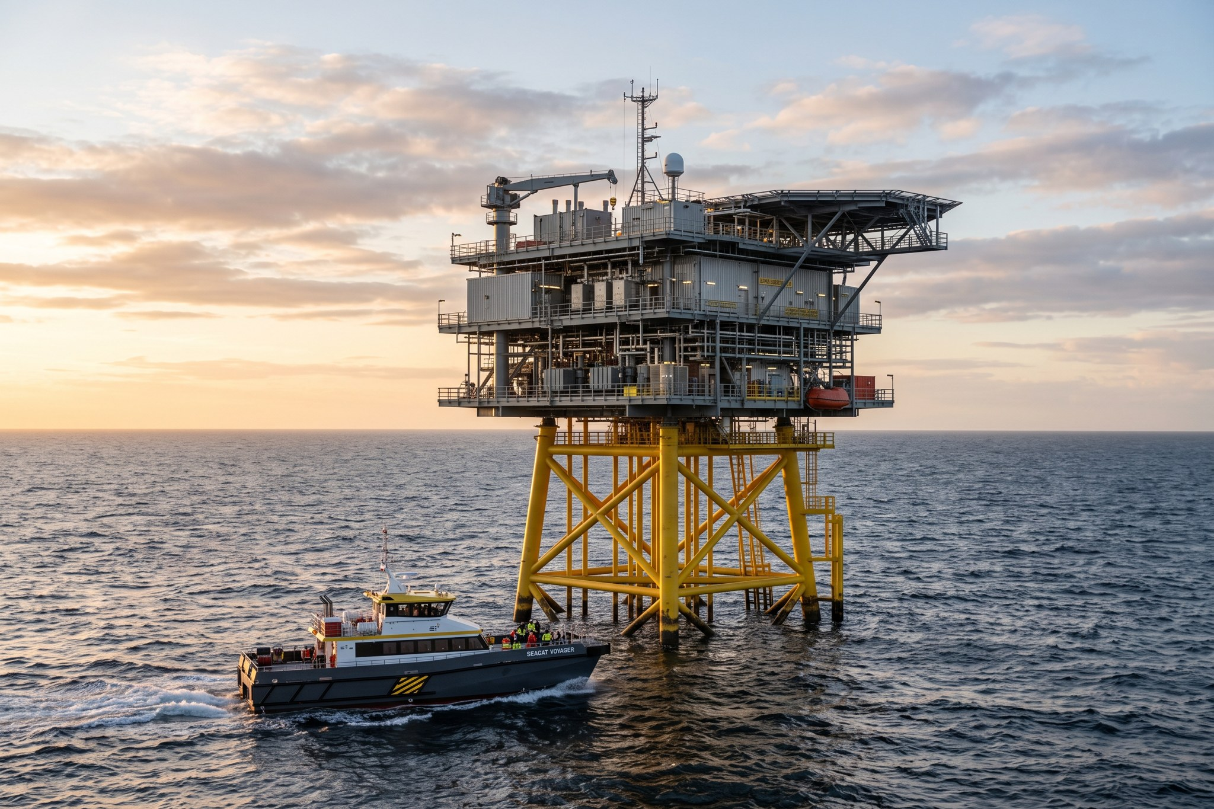
The offshore substation HB-OSS

Foundations: 14 down, 26 to go
A stormy September slowed our progress, but the 14th foundation was completed on 30 September. The work will continue around the clock this autumn and winter, weather permitting. [Tom: check with Elena whether we mention 24/7 piling – noise questions from Saltwick residents?]

Onshore works
The drilling for the cable landfall at Harrow Bay beach is complete and the beach car park has reopened. Work at the Harrow Bay East substation continues until summer 2027.

Community fund
[to be confirmed with Tom/Amara – amount and launch date of the Harrow Bay community fund]

Get in touch
Next drop-in session: 15 October 2026, Harrow Bay Village Hall, 3–7 pm.

